2. Write a mapreduce and pig program to calculate the number of cases investigated under FBI code 32

MapReduce Program:

Driver Class:

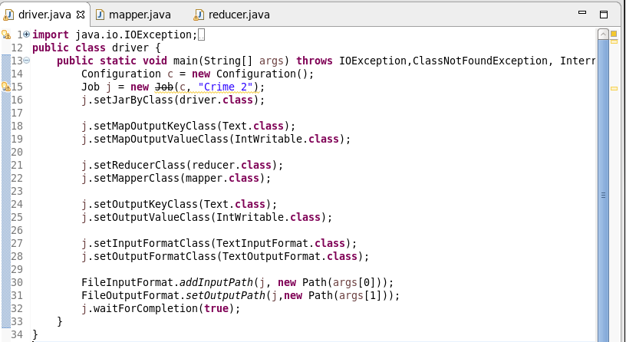

Here we are setting the job configurations in the Driver Class and setting the Output and Input File Formats for the Mapper in the line 18 and 19. In the line 21 and 22 we are setting the Mapper and reducer class.

Here I have taken the input and output format as the “Text Format class” in the line 27, 28.

Mapper Class:

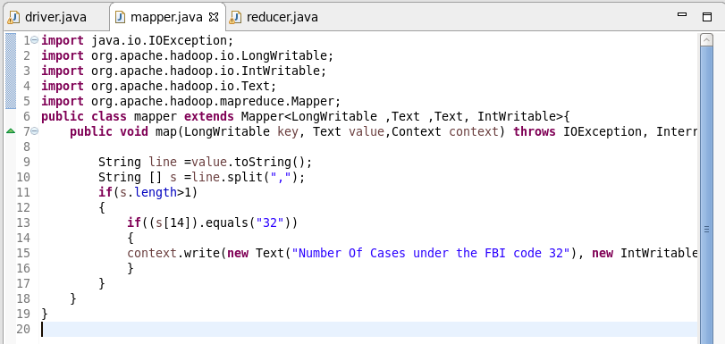

In the Mapper Class we are passing the key as the constant text as “Number of Cases under the FBI code 32 ” so the key will remain constant. Now the Output value is in intwritable format and is fixed as one so whenever code 32 comes up the output value one will be registered along with the constant key.

Reducer Class:

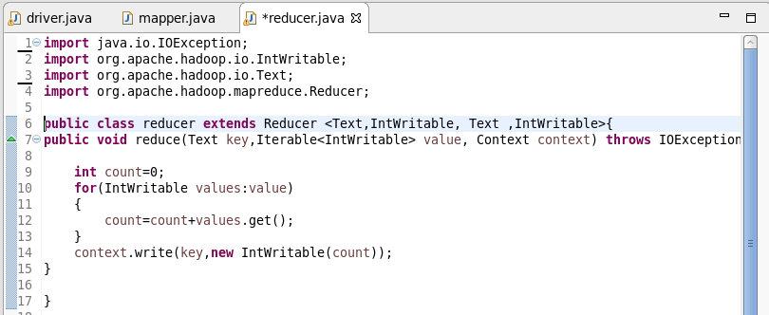

In the reducer we are summing up the values which are related each key and passing the key and the sum as the value in the intwritable format.

Here as we have the single key all the values related to that key will be added.

Running the Jar File:

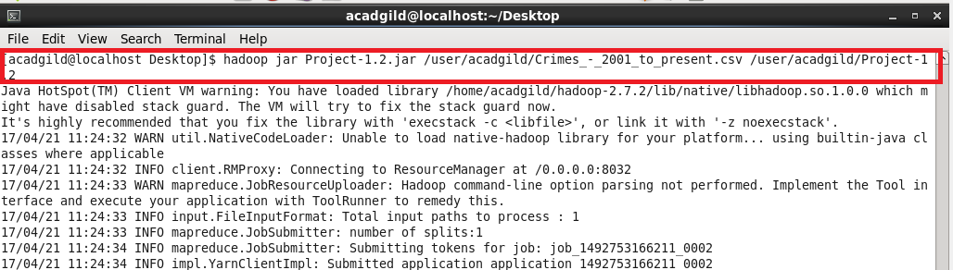

In the above screenshot, I have given the input path and output path while running the jar file.

Output:

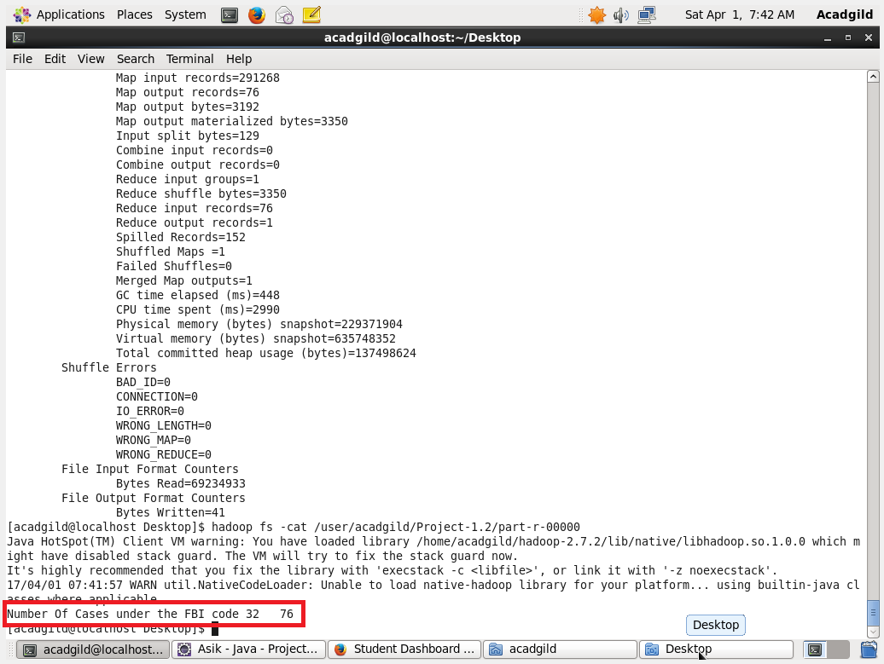

In the Output we can see that the Number Of Cases under the FBI code 32 is 76

Pig Program:

Pig Script:

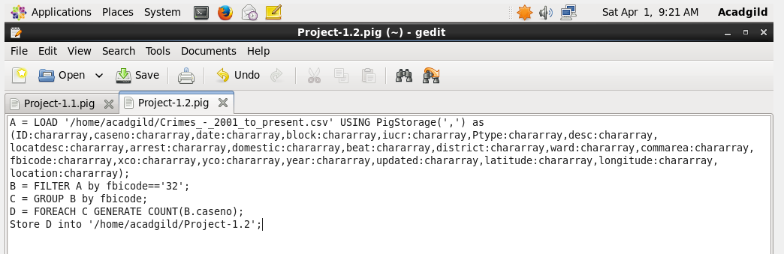

In the pig Script we have loaded the data according to the respective datatypes. Then filtered if the FBI code is 32. Then grouped by the code. Here there is only one code.

Then counted the codes which will give us the number of cases.

Running the Script:

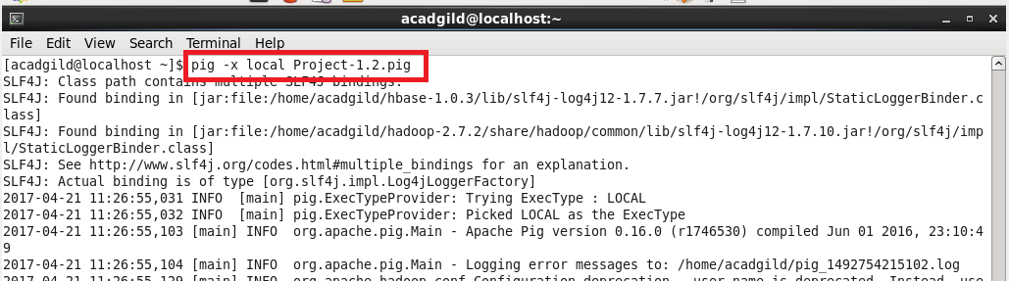

Output:

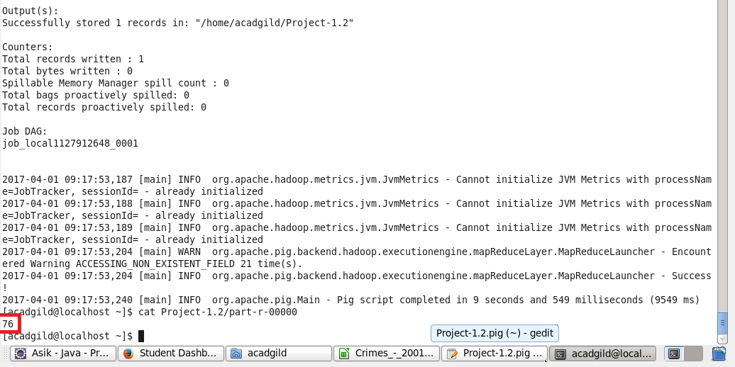

The Output of the Pig Program is 76 which is same as the MapReduce Program